

INFORMATION TECHNOLOGY EDUCATION DEPARTMENT

ITPROG2
(Computer Programming 2 for IT)

EXERCISE
2
Functions

score
Guillermo, Justine Rome  Name of Student | Lalata, JayAr  Name of Professor
JAN 12, 2019  Date Performed | JAN 12, 2019  Date Submitted

LABORATORY EXERCISE 2

A. Predefined Function: ceil(), floor(), rand(), srand()

PROBLEM #01
Create a program that will round off a given number.

EXAMPLE PROGRAM OUTPUT:
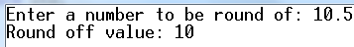 | 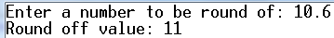
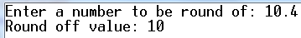 | 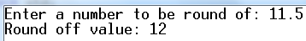

Program:

#include <iostream>
#include <math.h>
using namespace std;

int round (float num){

if( (num + 0.5) >= (int(num) + 1) )
num=ceil(num);
else
num=floor(num);

return num;
}

int main() {

float x;
cout << "Enter a number to be rounded of: ";
cin >> x;
cout <<"Round off value: "<<round (x);
return 0;
}

Output:
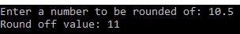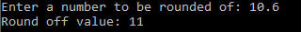
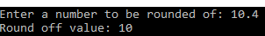

PROBLEM #02
Create a program that will generate 10 uniquely numbers ranges from 1 to 20.

EXAMPLE PROGRAM OUTPUT:
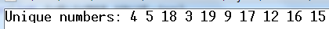 | 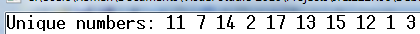
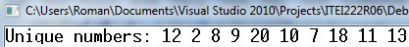 | 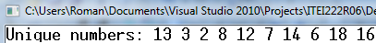

Program:
#include <iostream>
#include <cstdlib>
#include <ctime>
using namespace std;

int main(){
int i,r,j,num[10],n;
bool y;
srand(time(0));
cout << "Uniqe Numbers: ";

for(i = 0; i <= 9; i++){

do{
r = (rand() % 20)+1;
y = true;

for (j=0;j<i;j++){
if( r == num[j]){

y = false;
break;
}
}
}
while(!y);{
num[i] = r;
}
cout<<r<<" ";
}
}
Output:

PROBLEM #03

- Create a program compute the area of the following polygons and circle.
- Area of square given the side.
- Area of rectangle given the length and width.
- Area of triangle given the base and height.
- Area of circle given the radius.

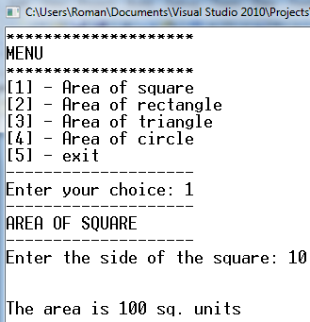 | 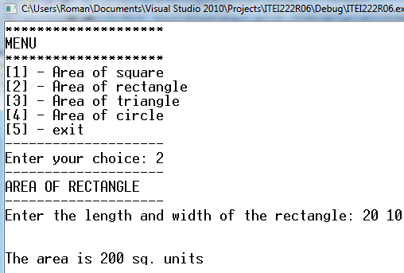
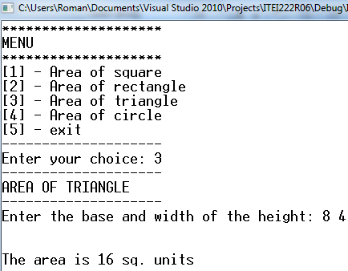 | 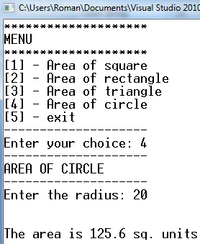

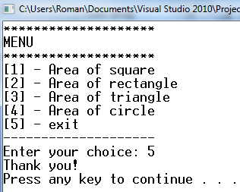

Program:
#include <iostream>
using namespace std;

int square(int y);
int rectangle (int x,int y);
int triangle (int x, int y);
int circle (int y);

int main (){
int x,y;

cout << "==================="<<"\nMENU"<< "\n===================";
cout << "\n[1] - Area of square\n";
cout << "[2] - Area of rectangle\n";
cout << "[3] - Area of triangle\n";
cout << "[4] - Area of circle\n";
cout << "[5] - Exit\n";
cout << "-------------------"<<"\nEnter your choice: ";
cin >> x;
cout<< "\n-------------------\n";

switch (x){

case 1:
square (y);
break;

case 2:
rectangle (x,y);
break;

case 3:
triangle (x,y);
break;

case 4:
circle (y);
break;
case 5:
cout << "Thank you!";
break;
default:
cout <<"your choice is invalid!";

}
}

int square(int y){
cout <<"AREA OF SQUARE\n";
cout <<"-------------------\n";
cout <<"Enter the side of the square: ";
cin >> y;
cout <<"The area is " <<y*y << " sq. units";
}

int rectangle (int x, int y){
int num [2];
cout <<"AREA OF RECTANGLE\n";
cout <<"-------------------\n";
cout <<"Enter the length and width of the rectangle: ";
for (int i=0; i<=1;i++)
cin >>num [i];
cout <<"The area is "<<num[0]*num[1]<<" sq. units";
}
int triangle (int x, int y){
int num [2];
cout <<"AREA OF A TRIANGLE\n";
cout <<"-------------------\n";
cout <<"Enter the base and width of the triangle: ";
for (int i=0; i<=1;i++)
cin >>num [i];
cout <<"The area is "<<(num[0]*num[1])/2<<" sq. units";
}
int circle (int y){
float pi=3.14, area;

cout <<"AREA OF A TRIANGLE\n";
cout <<"-------------------\n";
cout <<"Enter the radius of the circle: ";
cin >>y;
area = pi*y*y;
cout <<"The area is "<<area<<" sq. units";
}

Output:
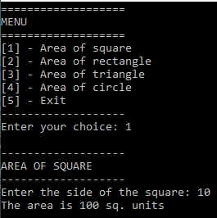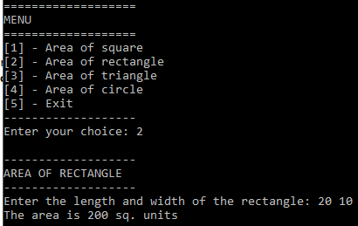

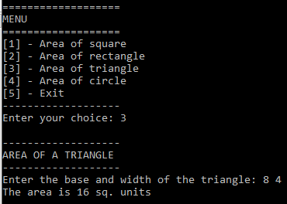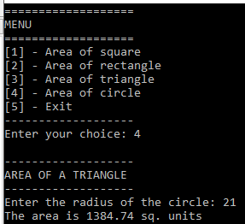

B. Call by value reference

- Create a program that will compute the factorial of a given number.
- Use function to pass the value of the number input and to pass the reference of the factorial value of the number.

Possible Output of the program:
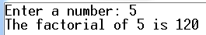 | 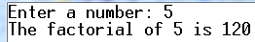

Program:
#include <iostream>
using namespace std;

int main (){

int x,n,f = 1;
cout << "Enter a number : ";
cin >> n;
x=n;
while (n >1){
f *= n--;
}
cout << "the factorial of " << x << " is "<< f <<endl;
return 0;
}
Output:
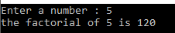

C. function max()

- Write a function max() which returns the greatest of two numbers. Test the function with a call from main() and complete with suitable printouts.

#include <iostream>
using namespace std;

int max(int x,int y){
int r;
if (x<y)
r=y;
else
r=x;
return r;

}

int main(){
int x,y;
cout <<"Enter first number: ";
cin >> x;
cout << "Enter second number: ";
cin >> y;
cout << max(x,y)<<" is the greatest of the two numbers";

}

